

Hot Rocks VOLCANO 2.0 oven installation procedure

TABLE OF CONTENTS
1 PRE-INSTALLATION REQUIREMENTS 3
2 INSTALLATION PROCEDURE ONCE OVEN IS IN PLACE 4
2.1 Powered on oven final installation 6
2.2 Stones installation 7
2.3 Reinstalls crumb trays and insulation panels 9
2.4 Install exit and entry conveyors 9
2.5 Internal components inspection before start up 11
2.5.1 Burner adjustment 12
2.6 Oven lubrication 15
2.7 Oven start up and heat up 17
3 QUICK FORMATION 18

This procedure purpose is to guide you through installation step check list and explain how to do them. This procedure excludes the installation lifting device operation you need to refer to operator manual.

PRE-INSTALLATION REQUIREMENTS

Be sure to have in hand the following documents:

- The installation check list
- The pre-installation requirements document signed
- The disclaimer for lifting device signed
- The installation lifting device operator manual

***See specs sheet for more detail for pre-installation space, electrical and gas supply requirements. ***

- Electrical Outlet 208-240V Single Phase with standard NEMA 6-50R female plug.
- Gas Line with Regulator.
- Gas connections are ready and installed on site. Gas hose with female quick connect as per specifications sheet requirements or equivalent is available.
- Ventilation hood as per local code requirements.

Install the oven and plug the oven following specs sheet ***Gas technician and electrician is required***. Follow installation device tool guide if required.

***See installation videos available for more details. ***
- https://installation.korokgroup.com/

INSTALLATION PROCEDURE ONCE OVEN IS IN PLACE

- If it is lower deck oven install leg and caster wheel before to rotate it. It is easier are safer when the oven is on the side.

Caster wheels can be fixed directly under the oven floor or can be raised using the provided leg if higher oven is required.

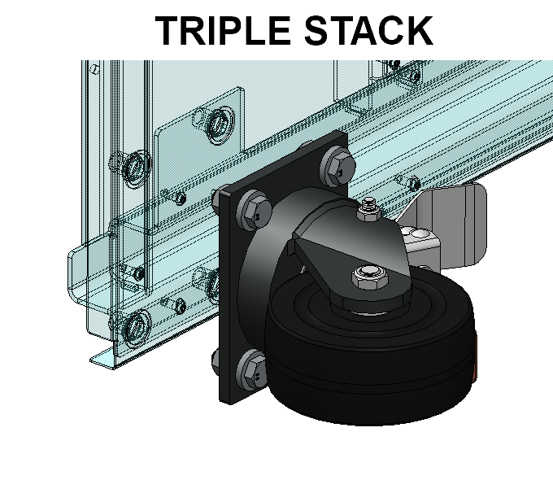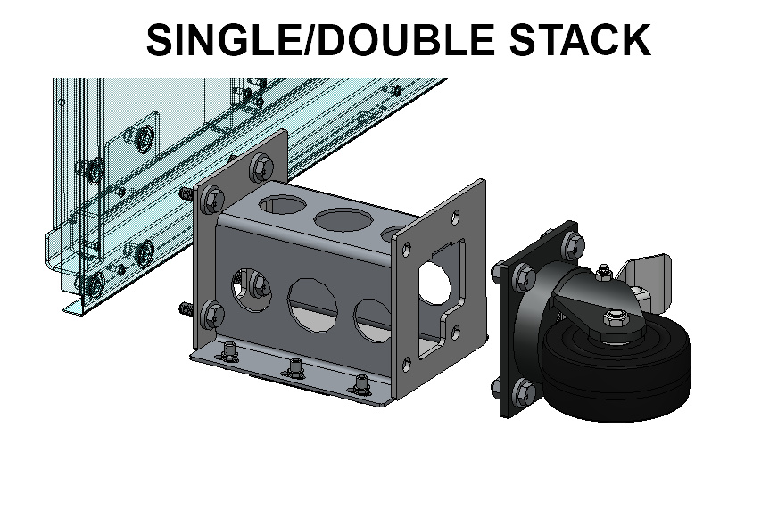

Instal caping plate once legs and wheels securely bolted to the oven floor

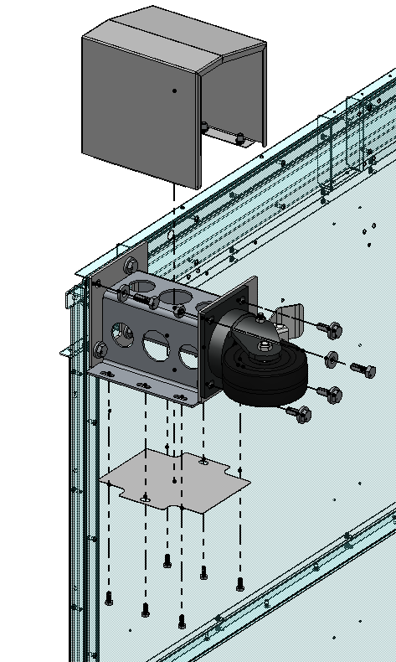

- For multiple decks, use self-tapping metal screws to secure ovens together. There are cross marks located in the back panel floor indicating where installing the screws.

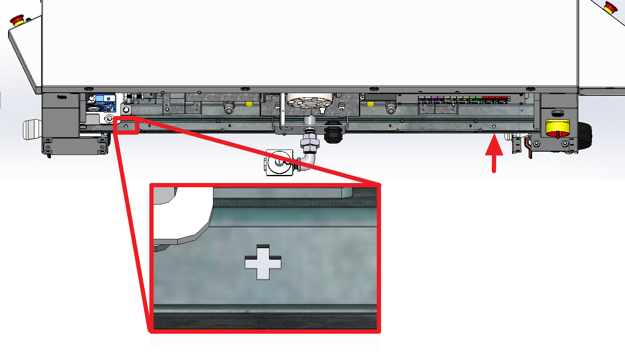

- For sanitary purposes, when installing multiple decks, a high temperature silicone sealant must be applied between each oven, refer to the image above to apply the silicone sealant. (Provided with the oven)
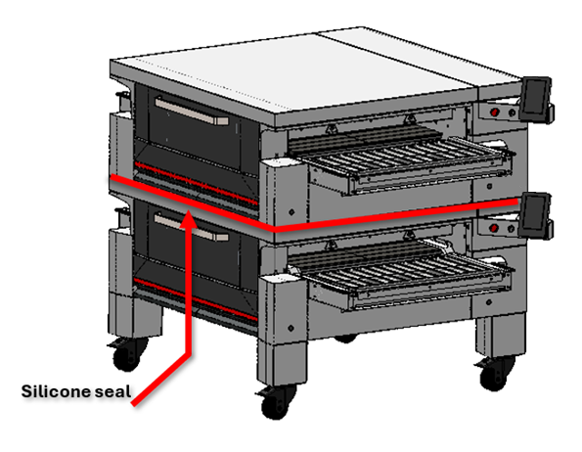

- Install the “U” bumpers behind the oven and assure that the oven is anchored to the floor or wall with the provided chain.

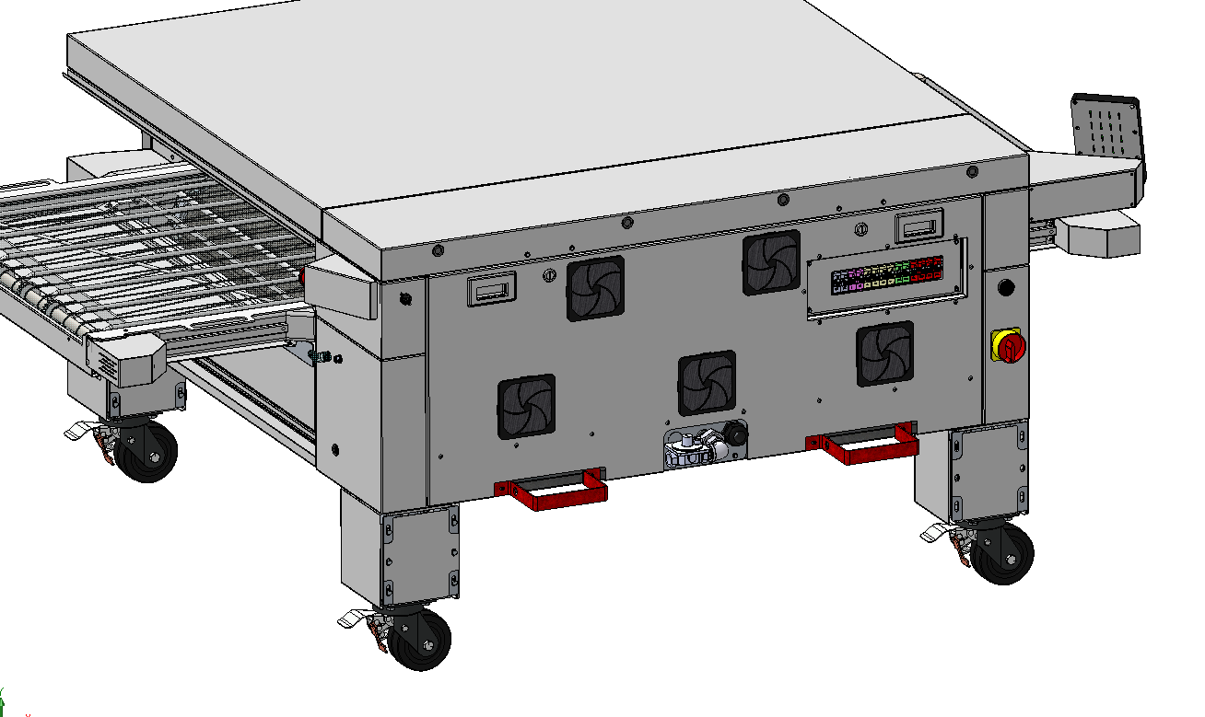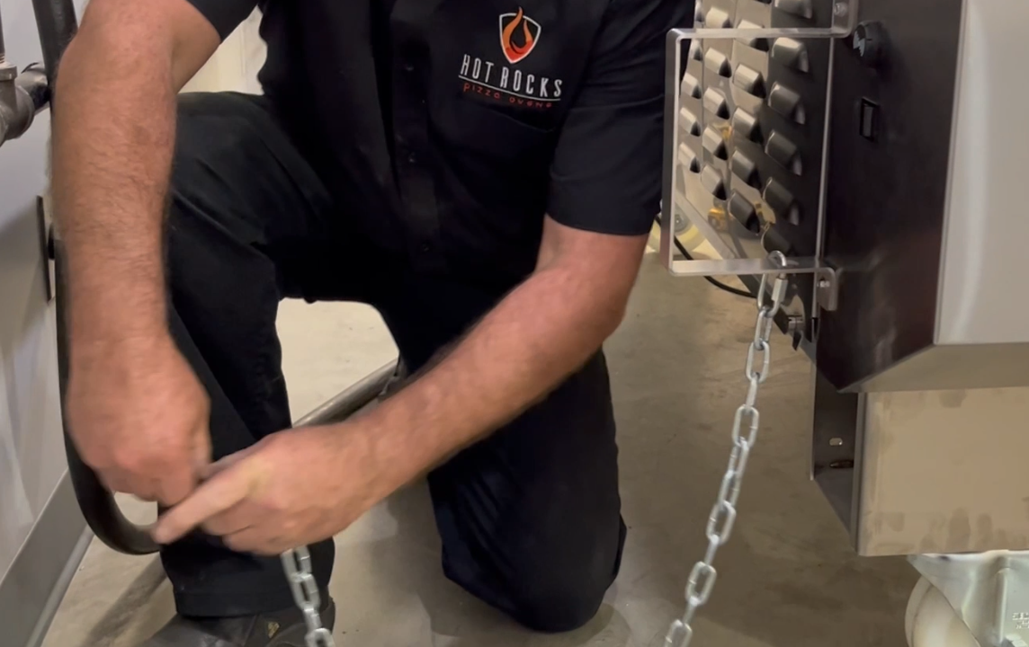
- Install the gas inlet.

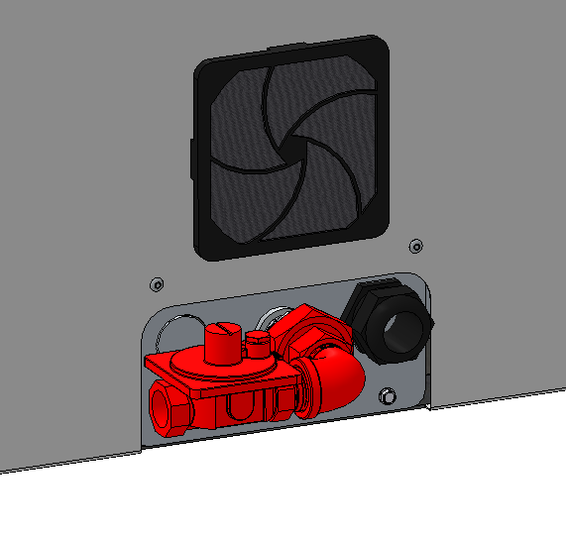
- Plug the electrical and gas power source. Be sure the gas type match with the sticker on the oven (natural or propane gas). The electrical plug provided with the oven is NEMA type 6-50-P ***A certified gas technician and electrician is required for this step***
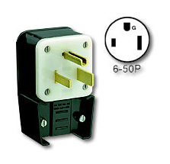

Install the control touch screen

PHOTO

Powered on oven final installation
***Be sure the oven is plugged and powered on. Power the oven with the main switch located at the rear left side, clear alarms if needed (Check ESTOP release buttons). See following instructions to reach the conveyor JOG menu panel to install the stones onto the chain conveyor.

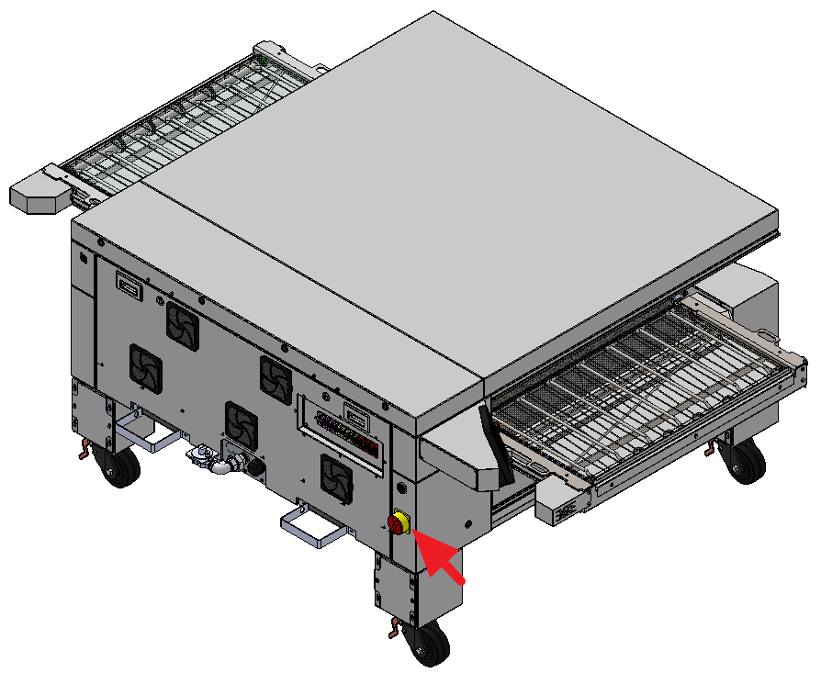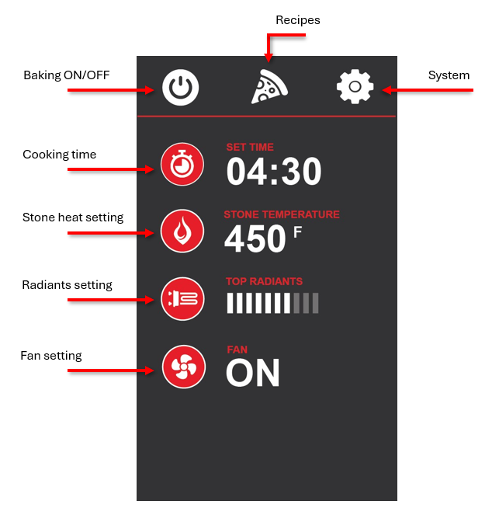

First click on the System icon on the main screen

Enter password pin number “911”

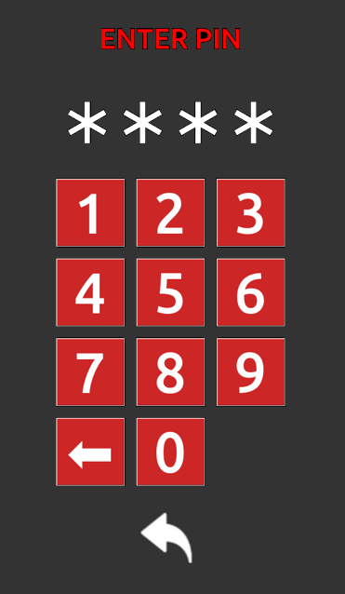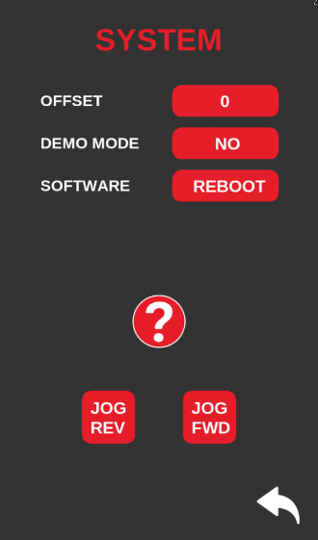

Then use the JOG button to move forward or backward the conveyor to instal the stones

Stones installation

From there use this panel to jog the conveyor and install the stones onto the chain conveyor.

Carefully follow the steps below to ensure the stone holder are properly fixed.

Remember when using the JOG option, you need to hold the button to keep the conveyor moving.

Drop tht stone and internal holder assembly straight in the external holder already in place in the oven. Be sure the holder is completely down and the hook are align with the slots | 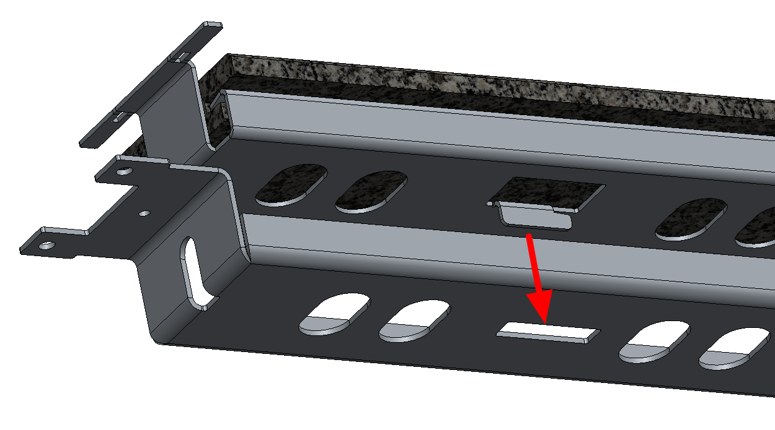
Slide the stone latteraly to engage the hook in the supporting holder. | 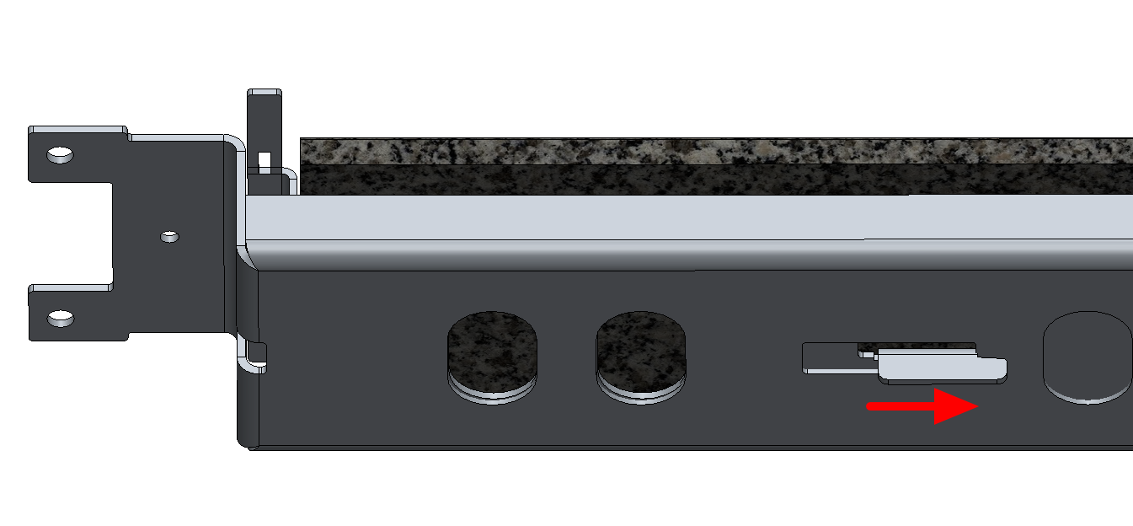
Bend the tabs down to secure the stone in place. Shake it to be sure it is secured in place. | 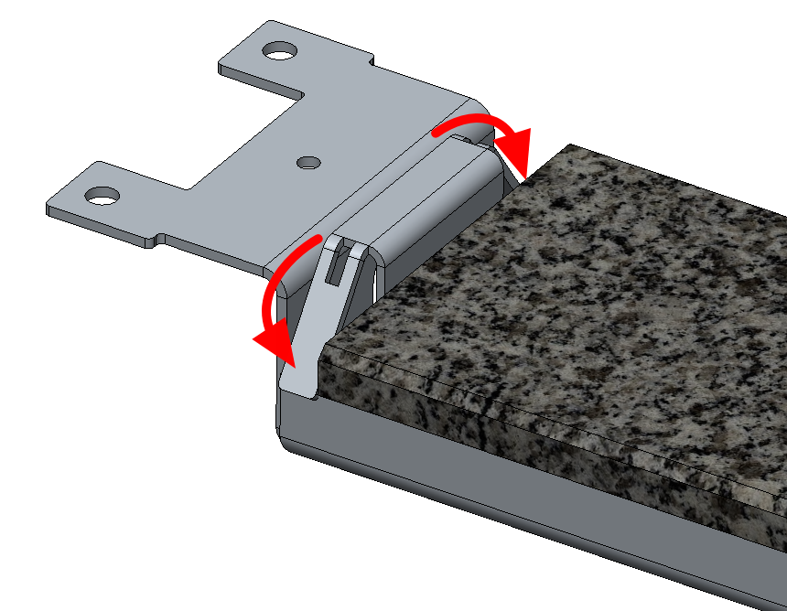

- Install stones.
- Verify if there are any loose rollers. Tight any loose one on principal chain during stone installation

- Verify the conveyor motor rotation. Rotation can be reversed simply using the selector switch located next to the touch screen.

- Verify convection fan motor rotation, you must feel air blowing in the oven be sure the burner is off and be in the output testing menu.
- Verify the emergency stop buttons works.

Install exit and entry conveyors

Identify which assembly is the entry and exit conveyors. Entry conveyors arm goes over the stone surface and their fixation are shaped as shown. Exit conveyors arm goes lower than stones surface as shown.

Fix the conveyor arms using the provided countersink bolt located in the fixation blocs.

Plug the 4 pins connector in the oven. ***Carefully align the connector notch***

Install the mesh conveyor by simply drop it on the conveyor arm. Align the location pin.

Adjust the conveyor height. Mesh should be 1/8” over the stone surface to avoid contact. Use the height adjustment screws shown.

Engage the conveyor drive by pulling and turn ½ the side handle.

Install the crumb trays under the mesh conveyors.

- First install the conveyor arms on both ‘Front’ and ‘Back’ of the Entry side. ***Don’t force the back motorised arm in place, be sure the hex drives male and female parts are aligned before bolt torquing. ***

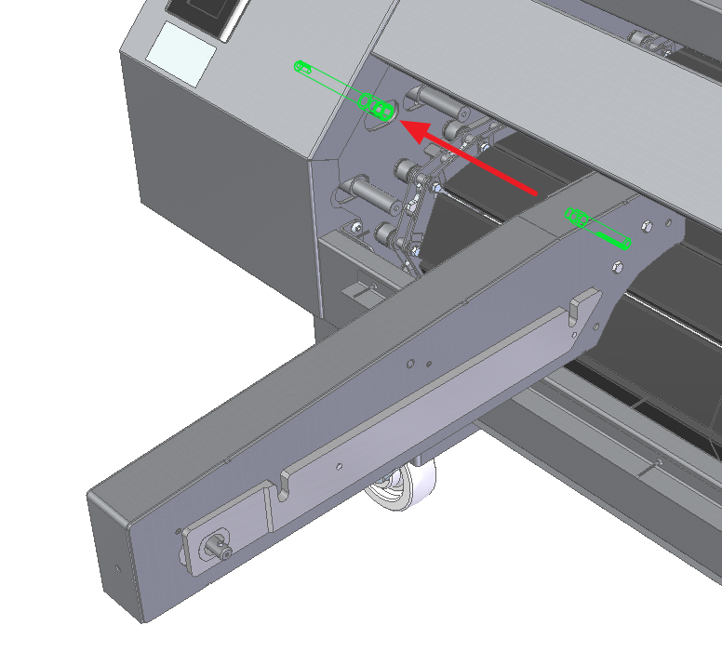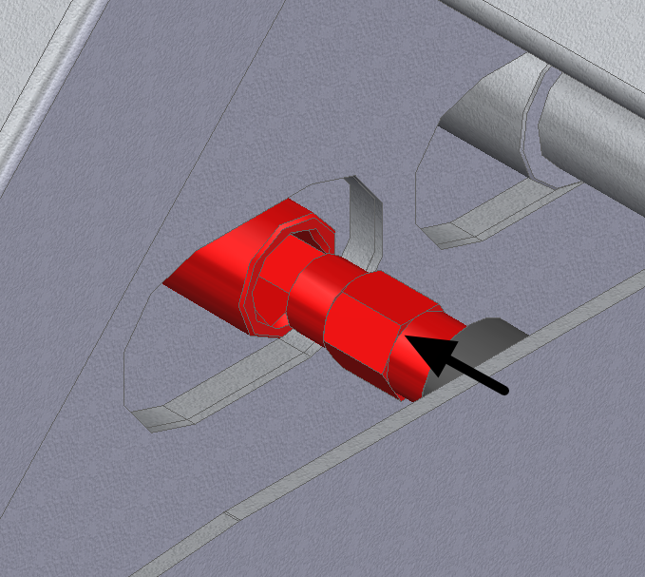

Install the mesh belt onto the Entry side, make you sure engage the side clutch.

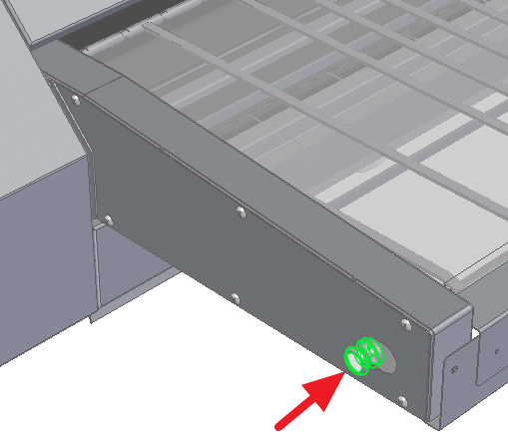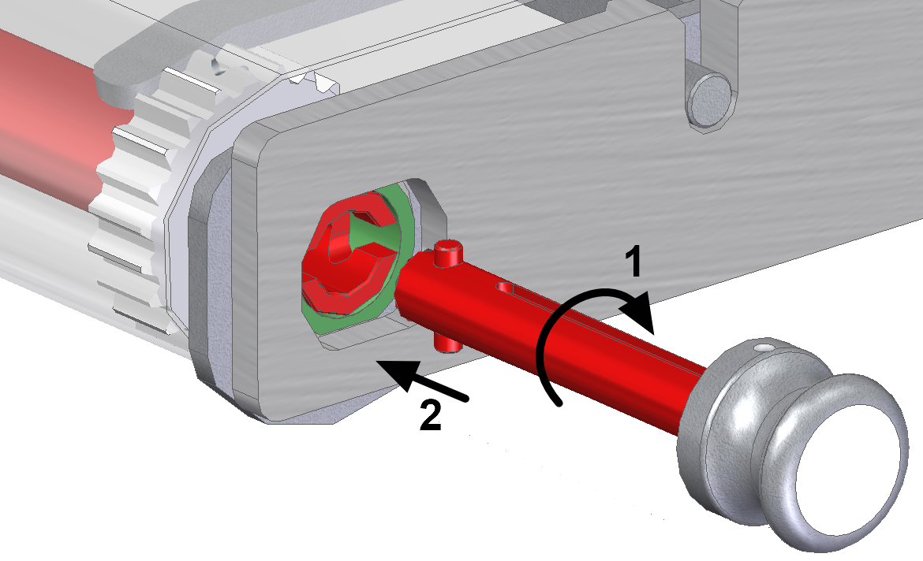

- Install the end covers with both screws.
- Install the crumb tray plates underneath the mesh belt.
- Adjust the height of the mesh conveyor with each side set screw. Use a 1/8-inch spacer, to have equal space between stone and mesh.

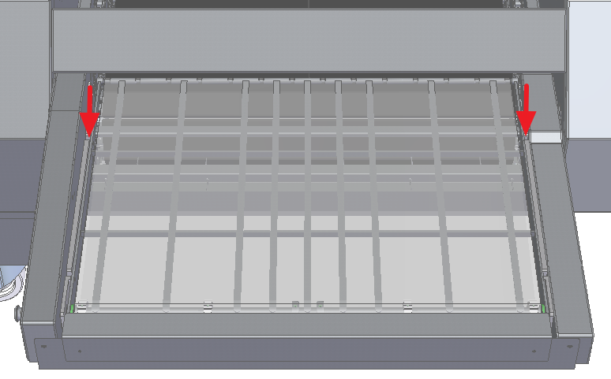

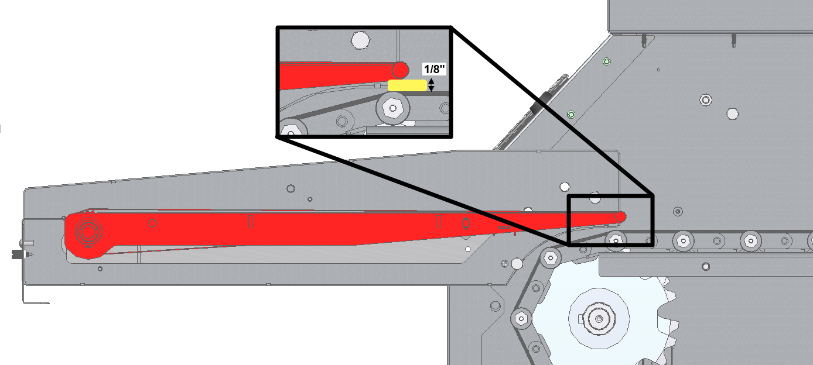
- Now repeat these steps for the exit conveyor side.

Internal components inspection before start up
***Be sure the oven is powered off and gas closed for next steps and remove backside panels

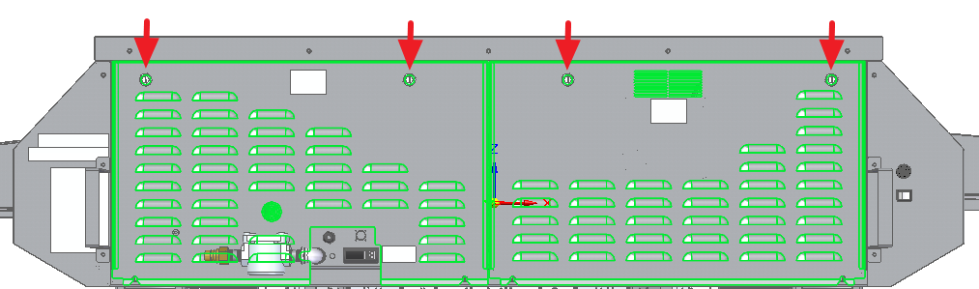

- Verify and visually inspect the wires connections, the terminal strips and contacts.

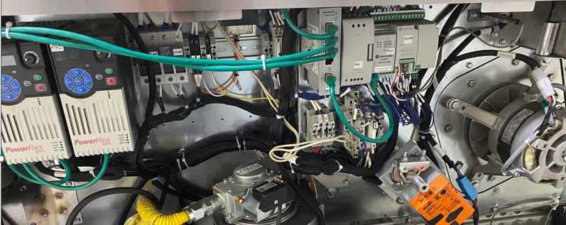

Burner adjustment

***Burner has been adjusted from factory before shipping.

Re-adjust the burner and flame rod only if burner issue occur during start up ***

Remove the burner, follow these steps;
  - Remove the gas hose from the burner valve
  - Unscrew and pull off the control plug from the burner valve
  - Pull off the power plug from the burner fan motor
  - Pull off the control plug from the burner fan motor
- Remove the spark, ground and sensor wires from the ignition box, (Use Pliers)
- Remove both nuts holding the assembly to the back panel
- You can now safely pull off the burner assembly from the oven

- Verify that the Flame sensing rod is at 1/4 inch from the burner’s membrane and no membrane fabric fiber touch it

- Re-install burner in place
- Open the inlet gas port with a 3/32 flat screwdriver and plug a gas manometer reader in the inlet gas port, this port is on the left-hand side of control valve of the burner.

- Remove plexicover Fenwall protection plate
- Locate the test terminals (FC+) (FC-) in the back of the ignition box, then plug a DVM set on µAmps.
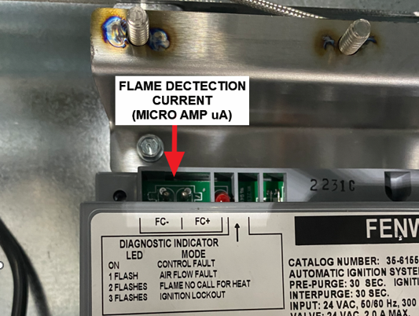

- Open line gas valve

- Verify the gas valve pressure inlet when the oven is off: Pressure must be between 6 and 12 inH₂O (W.C.) and measure the static pressure with the oven still at the ‘OFF’ position. If the reading is above those figures, DO NOT TURN THE OVEN ON. The inlet pressure is too high and could damage the electric valve on the burner. The supply line regulator must be adjusted.
Value: ______ inH₂O (W.C.)

- Power up the oven
- On the main screen set the bottom temperature at 400 F and start the oven.
- Measure current on Fenwal ignition box test terminals, must be at least 3.0 µA on low fire. You should measure a current above 3 µAmps, 5.5 µAmps and above being a typical reading. This reading is obtained when the burner is in Low fire mode or Infrared mode use the peeping tube to monitor the burner activity.
Value : ______ µA
- Verify the gas valve pressure inlet again when the oven is on high fire and all others equipment on the same pressure regulator are in operation. Pressure must be between 6 and 8 inH2O (W.C.). It can be adjusted with the inner regulator on the left-hand side of the burner.
Value : ______ inH2O (W.C.)

- Verify the gas valve pressure outlet: -0.01 to 0.00 inH₂O (W.C.) when the burner is lit on low fire. Brass port on the right hand side of control valve of the burner.
Value : ______ inH₂O (W.C.)
- Power off the oven
- Unplug measuring instruments
- ***Re-install panels. Verify that all the panels and covers are properly fastened Reassemble all the components and make sure everything is tight & tidy.

Oven lubrication

- Lubricate the main conveyor chain with the oven with lubrication mode. You can see steps in Owner’s Manual to know how to access lubrication mode.
- Go to the “LUBRICATION” setup page and start the lubrication. The oven will adjust itself to the proper settings for the lubrication.
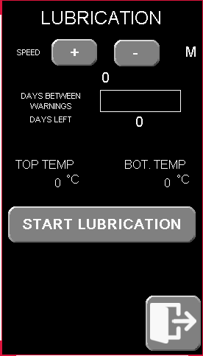

- For best results and avoid oil spillage in crumb tray wait about 30 minutes to let the oven reach these settings.
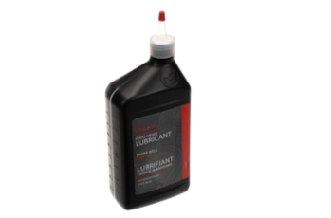
- Shake the lubricant bottle for 2 minutes. This food grade lubricant is designed for Hot Rocks application. No other lubricant will provide adequate lubrication. Using a different lubricant will remove the warranty on parts that require “EXTREME TEMPERATURE FOOD GRADE LUBRICANT”.
- Remove the top end cover. The entry or exit conveyor can be removed too for easiest reach. Open the chain guard entry and exit cover to access chains.
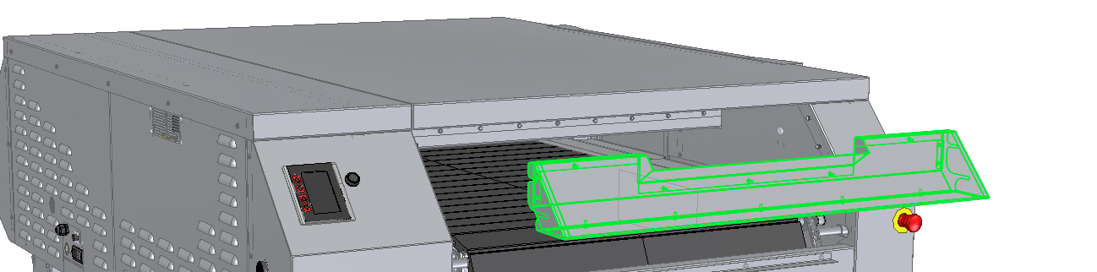
- Apply lubricant (FO75-0050) to each link of the chain as shown by a yellow strip in the illustration below. Repeat the process for the other chain of the stone conveyor. There are 6 months worth of lubricant in each container. Use a meat injector syringe with needle for easiest oil application.
- After applying lubricate to both sides of the conveyor, leave the oven working 30 minutes to let the oil evaporate.
- Reinstall the removed panels and operate the oven as usual. Depending on the amount of lubricate applied the excess lubricant will evaporate. The evaporation will produce a temporary odorous non-toxic smell and vapor.

Oven start up and heat up

***On the main screen set the bottom temperature at 400 F,top temperature at 500 F, 80% fan, and 2 min. conveyor speed, start the oven.
- Verify if the crumb trays under the main conveyor are placed correctly. Crumb trays not pushed in completely will result bad temperature reading and bad cooking consistency.

- Start the oven and wait for temperature ramp up at 400F
- Verify that the burner working well and maintain it during 1 hour. (Verify the burner modulate high and low fire)
- Verify that the oven reach and maintain temperature at the customer baking temperature
- Verify for cracked stone once the oven has reached 400°F
- Verify electrical current (Max 10A) with fan at 100% and time at 2 minutes.
- Verify that oven temperature is accurate, compare with high limit temperature probe behind the oven (max 90°F difference)

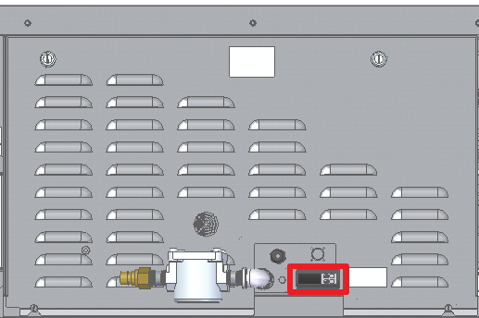

QUICK FORMATION

FINAL INSPECTION
- Look for cracked stones
- Verify that all the panels and covers are properly fastened
- Clean up the ovens
- Clean your work space, remove all wooden crates or packaging material.

Owner training
- Show the customer how to daily maintain the oven. Use the wall chart in the welcome kit
- Show the customer how to lube the main conveyor chain. The chain must be lubed every month.
- Go through the main screen user interface and make sure he customer can navigate and understands the different settings (Top temperature, bottom temperature, fan speed, cooking time..)
- Explain to the customer that, in case of an issue with the oven, he needs to contact our service department by visiting our support web page at: https://installation.korokgroup.com/

- Understand how to use the oven in a proper and secure fashion
- Understand how the digital control panel works.
- Understands maintenance, maintenance schedule, and schedule is displayed on the wall
- Understand who to contact for service



2555, Alfred Nobel, Drummondville
(Québec) Canada J2A 0L5
T : 819 395-5151 / 855 395-5252
F : 819 395-5343

Follow-us

